Aidan Kiser

24 October 2023

COMP-3350

HW8 Screenshots

Number 2a:

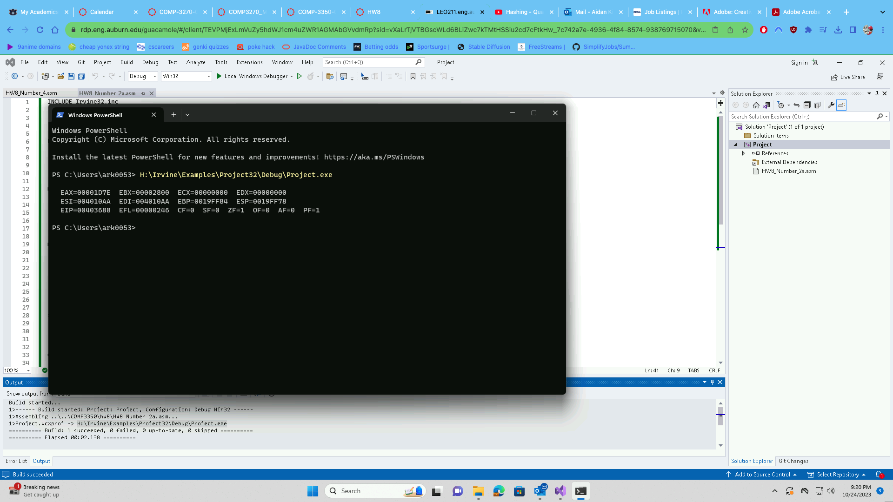

Number 2b:

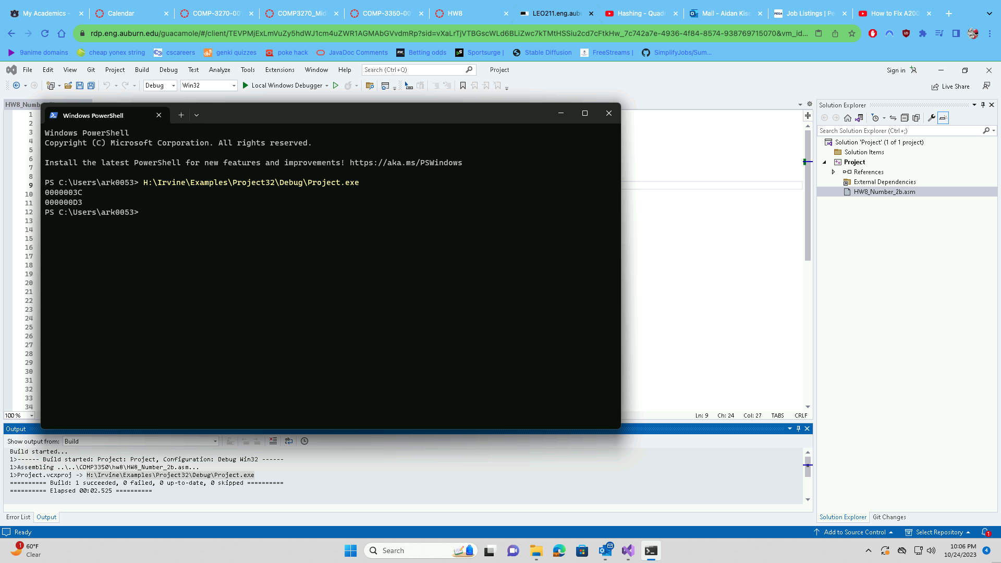

Number 4:

